

Faculty of Computer Applications
MCA Sem-1
(AY-2026-27)

Lab Book

Sub Code: 05MC0108
(DBMS)

Enrollment No : | 92600584037
Full Name : | Darshit Mehta

Subject Faculty Name: Prof. Amit Gohel

Index
Unit : 1  Exercise No | Unit : 1 Definition
1 | Write a PL/SQL block that find  1. Area of Circle  2. Area of Rectangle  3. Circumference of Circle
2 | Write a PL/SQL block to accept product name, qty and price from user and then calculate discount in Rs. based on the given (%).
3 | Write a PL/SQL block to calculate the total, percentage and grade of  student based on his/her Rollno from RESULT table. (Create RESULT  table with Rollno, Name, Sub1, Sub2, Sub3, Sub4, Sub5, Total, Per,  Grade attributes with appropriate data type).
4 | 1. Write a program that prints value 1 to 100 numbers using FOR LOOP.  2. Write a program that prints value 1 to 100 number using LOOP Command.  3. Write a program that prints value 1 to 100 number using WHILE LOOP.
5 | Write a PL/SQL block which displays gross salary of employees as per  user input EID. (Consider EMP table with EID, EName, Deptno,  Deptname Gender, Age, BasicSal) with appropriate data types.)  Gross_Salary: BASICSAL + (DA + HRA + Medical) – PF. Rules: HRA =  15% of basic, DA = 50% of basic, Medical = Rs. 500, PF = 10% of  basic.
6 | Write a PL/SQL block which accepts measurement in feet and displays it in cm, inch and meter.
7 | Write a PL/SQL block which converts temperature from Celsius to Fahrenheit.
8 | Write a PL/SQL block to delete the record of employee for given EID.
9 | Write a PL/SQL block that calculates the simple interest based on given principal amount, rate of interest and number of years.
10 | Write a PL/SQL block to calculate the square and cube of the given number.
Unit : 2  Exercise No | Unit : 2 Definition
11 | Write a simple procedure that increases by the salary of employees for  the given department no. by percentage inputted by the user using IN  parameter. Also, handle the exception if inputted department number  not found.
12 | Write a procedure that search whether the given employee number is  present or not in the table if present then print name, salary and  department number of that employee. (Use both IN and OUT mode  variables) and Write a PL/SQL block to call the SEARCH_EMP procedure.
13 | Write a procedure that accept employee ID and remove records from  employee table. Also, create a calling program to call procedure.
14 | Write a function that returns the age category of an employee.  Categories:  Age < 18 -> Minor  18 to 60 -> Adult  Age > 60 -> Senior
15 | Write a PACKAGE which includes Package Declaration, Package  Body and call the individual object from the Package.
Unit : 3  Exercise No | Unit : 3 Definition
16 | Write a trigger to insert the existing values of the EMP table into  NEWEMP table when the record is deleted from EMP table.
17 | Write a trigger to insert the existing values of the EMP table into  NEWEMP table when the record is updated in EMP table.
18 | Write a trigger to insert the values into the NEWEMP table when the  records are inserted into the EMP table.
19 | Write a trigger that restricts the entry of record if salary is greater than  Rs.50000.
20 | Write a trigger to restrict user form using the table on Sunday.
Unit : 5  Exercise No | Unit : 5 Definition
21 | Create a database with name emp_data & perform following  - Create collection : employee & insert data as per given table  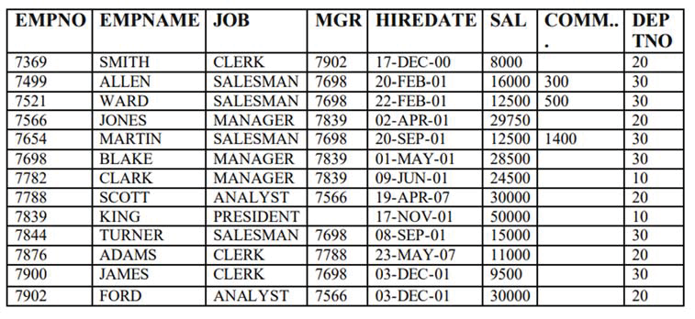  - Create collection: Department & insert data as per given table.  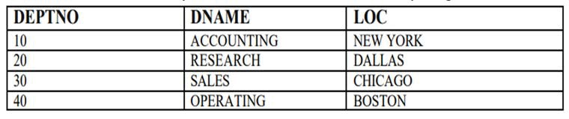  - Show all databases.  - Show currently selected database.  - Display all employee records.  - Display details of employees working as CLERK.  - Retrieve employees belonging to department number 30.  - Find employees whose salary is greater than 20000.  - Display employees whose job is SALESMAN.  - Retrieve employees who do not belong to department 10.  - Display employees with salary between 15000 and 30000.  - Find employees whose commission is not null.  - Display employees whose job is MANAGER and department is 20.  - Retrieve employees hired after 01-JAN-01.  - Display employees hired before 01-JAN-01.  - Find employees whose salary is less than or equal to 10000.  - Display employees whose name starts with ‘S’.  - Find employees whose name contains ‘AR’.  - Retrieve employees working under manager 7698.  - Display employees whose job is ANALYST or CLERK.  - Find employees who belong to either department 10 or 20.  Display only empno, empname, and salary of all employees.
22 | Prepare following collection & solve queries:  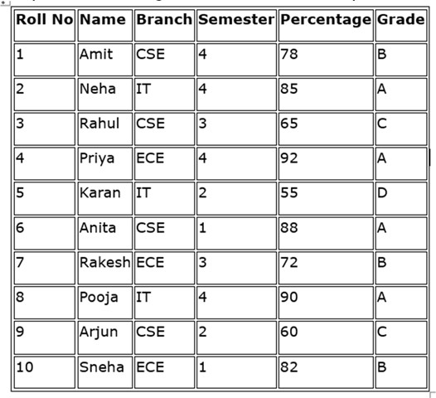  - Display all documents from the student collection.  - Retrieve details of students belonging to the IT branch.  - Find students whose percentage is greater than 75.  - Display students who are in semester 3.  - Retrieve students having grade = ‘A’.  - Display only name and branch of all students.  - Find students whose percentage is less than 60.  - Display students from CSE branch and semester 4.  - Retrieve students whose percentage lies between 65 and 85.  - Find students who are not from ECE branch.  - Display student records sorted by percentage in ascending order.  - Display student records sorted by name in descending order.  - Retrieve top 5 students based on percentage.  - Find students whose name starts with letter ‘A’.  - Find students whose name contains ‘ra’.  - Display students who belong to either CSE or IT branch.  - Retrieve students who are neither in semester 1 nor semester 2.  - Display only roll number, name, and percentage (exclude _id).  - Find students whose percentage is greater than or equal to 90.  Retrieve students whose grade is not equal to ‘D’.
23 | - Create a database named “mydb”  - Show all databases.  - Show currently selected database.  - Create a collection named “emp”.  - Show all collections of selected database.  - Insert following documents in emp collection:  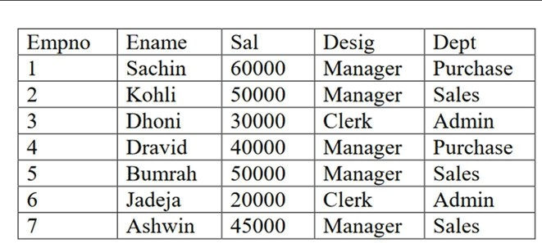  Find()  - List all documents.  - List all documents with formatted output.  - List the document of employee whose name is “achin”  - List the documents of employee whose salary is less than 30000  - List employees whose designation is manager and  - department is sales.  - List employees whose salary is less than 50000 and designation is manager or department is admin.  - Arrange the records by name in descending order.  - List first 3 documents of emp collection.  - Skip first 3 documents of emp collection.  - List 3rd and 4th documents of emp collection.  - Count no. of employees.  - List distinct designation.  Aggregate()  - Calculate annual salary of employees  - Display no. of employees designation wise.  - Display total salary of employees department wise.  - Display employee whose salary is highest.  - List highest salary of the employee department wise.  Calculate total salary of employees department wise and list whose total is greater than 70000.

1. Write a PL/SQL block that find:
1. Area of Circle
2. Area of Rectangle
3. Circumference of Circle

/*
Write a PL/SQL block that find
1 . Area Of Circle
2 . Area Of Rectangle
3. Circumference of Circle
*/

SET SERVEROUTPUT ON;

DECLARE
r NUMBER;
l NUMBER;
b NUMBER;
area_circle NUMBER;
area_rectangle NUMBER;
circumference NUMBER;
BEGIN
r := &radius;
l := &length;
b := &breadth;

area_circle := 3.14 * r * r;
area_rectangle := l * b;
circumference := 2 * 3.14 * r;

DBMS_OUTPUT.PUT_LINE('Area of Circle = ' || area_circle);
DBMS_OUTPUT.PUT_LINE('Area of Rectangle = ' || area_rectangle);
DBMS_OUTPUT.PUT_LINE('Circumference of Circle = ' || circumference);
END;
/SET SERVEROUTPUT OFF
SET FEEDBACK ON
SET VERIFY ON

Output:

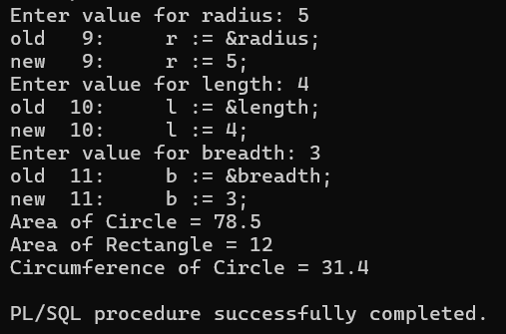

2. Write a PL/SQL block to accept product name, qty and price from user and then calculate discount in Rs. based on the given (%).

SET SERVEROUTPUT ON;

DECLARE
pname VARCHAR2(30);
qty NUMBER;
price NUMBER;
discount_per NUMBER;
total NUMBER;
discount_rs NUMBER;
net_amount NUMBER;
BEGIN
pname := '&Product_Name';
qty := &Quantity;
price := &Price;
discount_per := &Discount_Percentage;

total := qty * price;
discount_rs := (total * discount_per) / 100;
net_amount := total - discount_rs;

DBMS_OUTPUT.PUT_LINE('Product Name : ' || pname);
DBMS_OUTPUT.PUT_LINE('Quantity : ' || qty);
DBMS_OUTPUT.PUT_LINE('Price : ' || price);
DBMS_OUTPUT.PUT_LINE('Total Amount : ' || total);
DBMS_OUTPUT.PUT_LINE('Discount (Rs.) : ' || discount_rs);
DBMS_OUTPUT.PUT_LINE('Net Amount : ' || net_amount);
END;
/

Output:

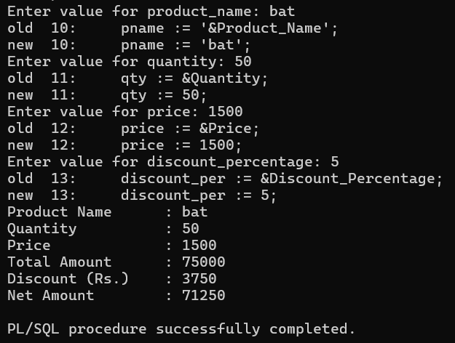

3. Write a PL/SQL block to calculate the total, percentage and grade of
student based on his/her Rollno from RESULT table. (Create RESULT
table with Rollno, Name, Sub1, Sub2, Sub3, Sub4, Sub5, Total, Per,
Grade attributes with appropriate data type).

-- Write a program to claculate grade

CREATE TABLE RESULT1 (
Rollno NUMBER(5) PRIMARY KEY,
Name VARCHAR2(50),
sub1 NUMBER(3) CHECK (sub1 BETWEEN 0 AND 100),
sub2 NUMBER(3) CHECK (sub2 BETWEEN 0 AND 100),
sub3 NUMBER(3) CHECK (sub3 BETWEEN 0 AND 100),
sub4 NUMBER(3) CHECK (sub4 BETWEEN 0 AND 100),
sub5 NUMBER(3) CHECK (sub5 BETWEEN 0 AND 100),
Total NUMBER(5),
Per NUMBER(5,2),
Grade VARCHAR2(2)
);

INSERT INTO RESULT1 (Rollno, Name, sub1, sub2, sub3, sub4, sub5)
VALUES (101, 'Harsh', 85, 90, 78, 88, 92);

INSERT INTO RESULT1 (Rollno, Name, sub1, sub2, sub3, sub4, sub5)
VALUES (102, 'Rahul', 60, 55, 70, 65, 58);

INSERT INTO RESULT1 (Rollno, Name, sub1, sub2, sub3, sub4, sub5)
VALUES (103, 'Priya', 95, 96, 98, 94, 97);

INSERT INTO RESULT1 (Rollno, Name, sub1, sub2, sub3, sub4, sub5)
VALUES (104, 'Amit', 45, 52, 48, 50, 55);

INSERT INTO RESULT1 (Rollno, Name, sub1, sub2, sub3, sub4, sub5)
VALUES (105, 'Neha', 72, 68, 75, 70, 74);

INSERT INTO RESULT1 (Rollno, Name, sub1, sub2, sub3, sub4, sub5)
VALUES (106, 'Karan', 30, 65, 72, 80, 69);

INSERT INTO RESULT1 (Rollno, Name, sub1, sub2, sub3, sub4, sub5)
VALUES (107, 'Sneha', 88, 84, 91, 86, 90);

INSERT INTO RESULT1 (Rollno, Name, sub1, sub2, sub3, sub4, sub5)
VALUES (108, 'Riya', 50, 47, 55, 60, 52);

COMMIT;

SET SERVEROUTPUT ON;

DECLARE
rno RESULT1.Rollno%TYPE;
sname RESULT1.Name%TYPE;
s1 RESULT1.sub1%TYPE;
s2 RESULT1.sub2%TYPE;
s3 RESULT1.sub3%TYPE;
s4 RESULT1.sub4%TYPE;
s5 RESULT1.sub5%TYPE;
total RESULT1.Total%TYPE;
per RESULT1.Per%TYPE;
grade RESULT1.Grade%TYPE;

BEGIN
rno := &Enter_Roll_No;

SELECT Name, sub1, sub2, sub3, sub4, sub5
INTO sname, s1, s2, s3, s4, s5
FROM RESULT1
WHERE Rollno = rno;

total := s1 + s2 + s3 + s4 + s5;
per := total / 5;

IF s1 < 35 OR s2 < 35 OR s3 < 35 OR s4 < 35 OR s5 < 35 THEN
grade := 'F';
DBMS_OUTPUT.PUT_LINE('RESULT : FAIL');
ELSE
IF per >= 90 THEN
grade := 'A+';
ELSIF per >= 80 THEN
grade := 'A';
ELSIF per >= 70 THEN
grade := 'B';
ELSIF per >= 60 THEN
grade := 'C';
ELSIF per >= 50 THEN
grade := 'D';
ELSE
grade := 'F';
END IF;

DBMS_OUTPUT.PUT_LINE('RESULT : PASS');
END IF;

DBMS_OUTPUT.PUT_LINE('---------------------------------------------');
DBMS_OUTPUT.PUT_LINE('Roll No : ' || rno);
DBMS_OUTPUT.PUT_LINE('Name : ' || sname);
DBMS_OUTPUT.PUT_LINE('Total : ' || total);
DBMS_OUTPUT.PUT_LINE('Percentage : ' || per || '%');
DBMS_OUTPUT.PUT_LINE('Grade : ' || grade);
DBMS_OUTPUT.PUT_LINE('---------------------------------------------');

END;
/

Output:

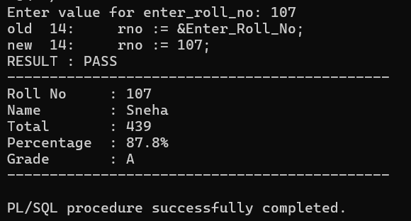

4.
4.1. Write a program that prints value 1 to 100 numbers using FOR LOOP.
4.2. Write a program that prints value 1 to 100 number using LOOP Command.
4.3. Write a program that prints value 1 to 100 number using WHILE LOOP.

4.1 Program to print numbers 1 to 100 using FOR loop

//DECLARE
// i NUMBER;
BEGIN
FOR i IN 1..100 LOOP
DBMS_OUTPUT.PUT_LINE(i);
END LOOP;
END;
/

4.2 Program to print numbers 1 to 100 using LOOP command

DECLARE
i NUMBER := 1;
BEGIN
LOOP
DBMS_OUTPUT.PUT_LINE(i);
i := i + 1;
EXIT WHEN i > 100;
END LOOP;
END;
/

4.3 Program to print numbers 1 to 100 using WHILE loop

DECLARE
i NUMBER := 1;
BEGIN
WHILE i <= 100 LOOP
DBMS_OUTPUT.PUT_LINE(i);
i := i + 1;
END LOOP;
END;
Output:

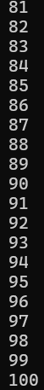

5. Write a PL/SQL block which displays gross salary of employees as per
user input EID. (Consider EMP table with EID, EName, Deptno,
Deptname Gender, Age, BasicSal) with appropriate data types.)
Gross_Salary: BASICSAL + (DA + HRA + Medical) – PF. Rules: HRA =
15% of basic, DA = 50% of basic, Medical = Rs. 500, PF = 10% of
basic.

CREATE TABLE EMP(
EID NUMBER(3) PRIMARY KEY,
EName VARCHAR(15),
Deptno NUMBER(3),
Deptname VARCHAR(30),
Gender VARCHAR(5),
Age NUMBER(3),
BasicSal NUMBER(10)
);

INSERT INTO EMP (EID,EName,Deptno,Deptname,Gender,Age,BasicSal)
VALUES (101,'Ronak',10,'Loan Department','Male',21,50000);

INSERT INTO EMP (EID,EName,Deptno,Deptname,Gender,Age,BasicSal)
VALUES (102,'Hit',20,'Finance Department','Male',20,75000);

INSERT INTO EMP (EID,EName,Deptno,Deptname,Gender,Age,BasicSal)
VALUES (103,'Pranav',30,'HR Department','Male',22,45000);

SET SERVEROUTPUT ON;

DECLARE
id EMP.EID%TYPE;
name EMP.EName%TYPE;
basic EMP.BasicSal %TYPE;

hra NUMBER;
da NUMBER;
medical NUMBER := 500;
pf NUMBER;
gross NUMBER;

BEGIN

-- Take Employee ID from user
id := &Enter_id;

-- Fetch employee details

SELECT EName, Basicsal
INTO name, basic
FROM EMP
WHERE EID = id;

-- Calculate salary components
hra := basic * 0.15;
da := basic * 0.50;
pf := basic * 0.10;

-- Calculate Gross Salary
gross := basic + da + hra + medical - pf;

-- Display Result --
DBMS_OUTPUT.PUT_LINE('--------------------------------------');
DBMS_OUTPUT.PUT_LINE('Employee ID : ' || id);
DBMS_OUTPUT.PUT_LINE('Employee Name : ' || name);
DBMS_OUTPUT.PUT_LINE('Basic Salary : ' || basic);
DBMS_OUTPUT.PUT_LINE('DA : ' || da);
DBMS_OUTPUT.PUT_LINE('HRA : ' || hra);
DBMS_OUTPUT.PUT_LINE('Medical : ' || medical);
DBMS_OUTPUT.PUT_LINE('PF : ' || pf);
DBMS_OUTPUT.PUT_LINE('Gross Salary : ' || gross);
DBMS_OUTPUT.PUT_LINE('--------------------------------------');

EXCEPTION
WHEN NO_DATA_FOUND THEN
DBMS_OUTPUT.PUT_LINE('Employee ID not found.');
END;
/

Output:
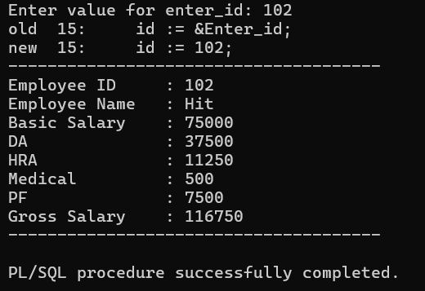

6. Write a PL/SQL block which accepts measurement in feet and displays it in cm, inch and meter.

SET SERVEROUTPUT ON;

DECLARE
feet REAL;
inch REAL;
cm REAL;
meter REAL;
BEGIN
-- Accept input
feet := &feet;

-- Conversion
inch := feet * 12;
cm := feet * 30.48;
meter := feet * 0.3048;

-- Display results
DBMS_OUTPUT.PUT_LINE('Measurement in Feet : ' || feet);
DBMS_OUTPUT.PUT_LINE('Measurement in Inches : ' || inch);
DBMS_OUTPUT.PUT_LINE('Measurement in CM : ' || cm);
DBMS_OUTPUT.PUT_LINE('Measurement in Meters : ' || meter);
END;
/

Output:
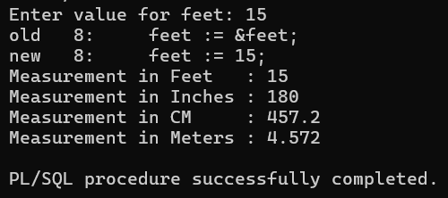
7. Write a PL/SQL block which converts temperature from Celsius to Fahrenheit.

SET SERVEROUTPUT ON;

DECLARE
celsius NUMBER;
fahrenheit NUMBER;
BEGIN
-- Accept input
celsius := &celsius;

-- Convert Celsius to Fahrenheit
fahrenheit := (celsius * 9 / 5) + 32;

-- Display result
DBMS_OUTPUT.PUT_LINE('Celsius = ' || celsius);
DBMS_OUTPUT.PUT_LINE('Fahrenheit = ' || fahrenheit);
END;
/

Output:

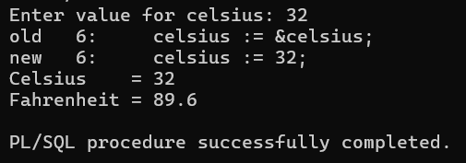

8. Write a PL/SQL block to delete the record of employee for given EID.

SET SERVEROUTPUT ON;

DECLARE
EID NUMBER;
BEGIN
-- Accept Employee ID
EID := &EID;

-- Delete record
DELETE FROM EMP
WHERE EID = EID;

-- Check if record is deleted
IF SQL%ROWCOUNT > 0 THEN
DBMS_OUTPUT.PUT_LINE('Employee record deleted successfully.');
ELSE
DBMS_OUTPUT.PUT_LINE('Employee ID not found.');
END IF;

COMMIT;
END;
/

Output:
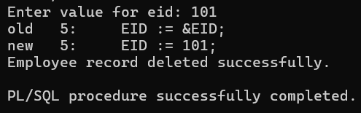

9. Write a PL/SQL block that calculates the simple interest based on given principal amount, rate of interest and number of years.

SET SERVEROUTPUT ON;

DECLARE
p NUMBER;
r NUMBER;
n NUMBER;
si NUMBER;
BEGIN
-- Accept inputs
p := &principal;
r := &rate;
n := &years;

-- Calculate Simple Interest
si := (p * r * n) / 100;

-- Display result
DBMS_OUTPUT.PUT_LINE('Simple Interest = ' || si);
END;
/

Output:
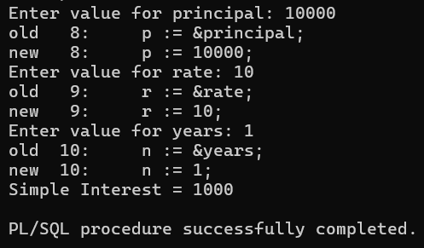
10. Write a PL/SQL block to calculate the square and cube of the given number.

SET SERVEROUTPUT ON;

DECLARE
num NUMBER;
square NUMBER;
cube NUMBER;
BEGIN
-- Accept input
num := &num;

-- Calculate square and cube
square := num * num;
cube := num * num * num;

-- Display result
DBMS_OUTPUT.PUT_LINE('Square = ' || square);
DBMS_OUTPUT.PUT_LINE('Cube = ' || cube);
END;
/

Output:
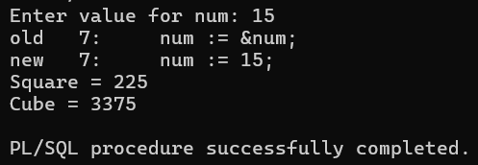

10. Write a simple procedure that increases by the salary of employees for
the given department no. by percentage inputted by the user using IN
parameter. Also, handle the exception if inputted department number
not found.

CREATE TABLE EMP1(
EID NUMBER(3) PRIMARY KEY,
EName VARCHAR(15),
Deptno NUMBER(3),
Deptname VARCHAR(30),
Gender VARCHAR(5),
Age NUMBER(3),
BasicSal NUMBER(10)
);

INSERT INTO EMP1 (EID,EName,Deptno,Deptname,Gender,Age,BasicSal)
VALUES (101,'Ronak',10,'Loan Department','Male',21,50000);

INSERT INTO EMP1 (EID,EName,Deptno,Deptname,Gender,Age,BasicSal)
VALUES (102,'Hit',20,'Finance Department','Male',20,75000);

INSERT INTO EMP1 (EID,EName,Deptno,Deptname,Gender,Age,BasicSal)
VALUES (103,'Pranav',30,'HR Department','Male',22,45000);

SET SERVEROUTPUT ON;

DECLARE
id EMP1.EID%TYPE;
name EMP1.EName%TYPE;
basic EMP1.BasicSal %TYPE;

hra NUMBER;
da NUMBER;
medical NUMBER := 500;
pf NUMBER;
gross NUMBER;

BEGIN

-- Take Employee ID from user
id := &Enter_id;

-- Fetch employee details

SELECT EName, Basicsal
INTO name, basic
FROM EMP1
WHERE EID = id;

-- Calculate salary components
hra := basic * 0.15;
da := basic * 0.50;
pf := basic * 0.10;

-- Calculate Gross Salary
gross := basic + da + hra + medical - pf;

-- Display Result --
DBMS_OUTPUT.PUT_LINE('--------------------------------------');
DBMS_OUTPUT.PUT_LINE('Employee ID : ' || id);
DBMS_OUTPUT.PUT_LINE('Employee Name : ' || name);
DBMS_OUTPUT.PUT_LINE('Basic Salary : ' || basic);
DBMS_OUTPUT.PUT_LINE('DA : ' || da);
DBMS_OUTPUT.PUT_LINE('HRA : ' || hra);
DBMS_OUTPUT.PUT_LINE('Medical : ' || medical);
DBMS_OUTPUT.PUT_LINE('PF : ' || pf);
DBMS_OUTPUT.PUT_LINE('Gross Salary : ' || gross);
DBMS_OUTPUT.PUT_LINE('--------------------------------------');

EXCEPTION
WHEN NO_DATA_FOUND THEN
DBMS_OUTPUT.PUT_LINE('Employee ID not found.');
END;
/
SET SERVEROUTPUT ON;

CREATE OR REPLACE PROCEDURE inc_salary(
deptno IN NUMBER,
percent IN NUMBER
)
IS
BEGIN
UPDATE EMP1
SET BasicSal= BasicSal+ (BasicSal * percent / 100)
WHERE Deptno = deptno;

IF SQL%ROWCOUNT = 0 THEN
RAISE_APPLICATION_ERROR(-20001, 'Department not found');
ELSE
DBMS_OUTPUT.PUT_LINE('Salary updated successfully.');
END IF;

EXCEPTION
WHEN OTHERS THEN
DBMS_OUTPUT.PUT_LINE(SQLERRM);
END;
/

----Execute the Procedure----
BEGIN
inc_salary(30, 10); -- Increase salary by 10% for Department 10
END;
/

Output:



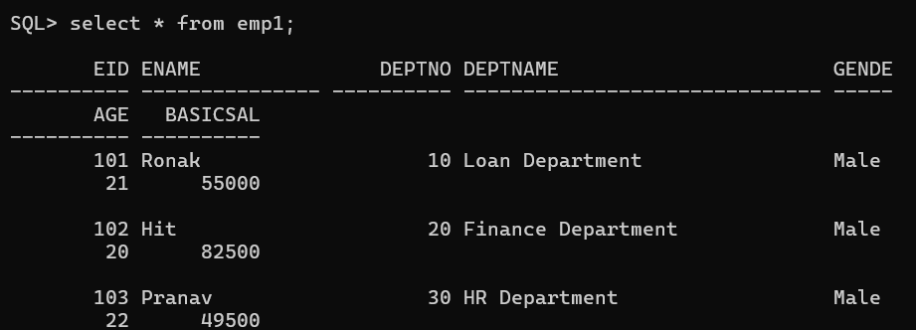

12. Write a procedure that search whether the given employee number is
present or not in the table if present then print name, salary and
department number of that employee. (Use both IN and OUT mode
variables) and Write a PL/SQL block to call the SEARCH_EMP procedure.

SET SERVEROUTPUT ON;

CREATE OR REPLACE PROCEDURE SEARCH_EMP(
P_EMP_ID IN EMP1.EID%TYPE,
P_EMP_NAME OUT EMP1.ENAME%TYPE,
P_EMP_SAL OUT EMP1.BASICSAL%TYPE,
P_EMP_DNO OUT EMP1.DEPTNO%TYPE
)
AS
BEGIN

SELECT ENAME, BASICSAL, DEPTNO
INTO P_EMP_NAME, P_EMP_SAL, P_EMP_DNO
FROM EMP1
WHERE EID = P_EMP_ID;

EXCEPTION
WHEN NO_DATA_FOUND THEN
DBMS_OUTPUT.PUT_LINE('EMPLOYEE ID ' || P_EMP_ID || ' NOT FOUND');

END;
/

DECLARE
G_NAME EMP1.ENAME%TYPE;
G_SAL EMP1.BASICSAL%TYPE;
G_DNO EMP1.DEPTNO%TYPE;
BEGIN

SEARCH_EMP(102, G_NAME, G_SAL, G_DNO);
DBMS_OUTPUT.PUT_LINE('EMPLOYEE NAME: ' || G_NAME);
DBMS_OUTPUT.PUT_LINE('BASIC SALARY: ' || G_SAL);
DBMS_OUTPUT.PUT_LINE('DEPARTMENT NO: ' || G_DNO);
END;
/

Output:

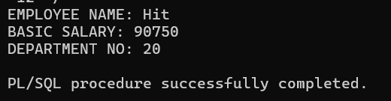

13. Write a procedure that accept employee ID and remove records from
employee table. Also, create a calling program to call procedure.

CREATE OR REPLACE PROCEDURE DELETE_EMP(
EMP_ID IN EMP1.EID%TYPE
)AS

BEGIN
DELETE FROM EMP1
WHERE EID=EMP_ID;

EXCEPTION
WHEN OTHERS THEN
DBMS_OUTPUT.PUT_LINE(TO_CHAR(EMP_ID) ||' NO DATA FOND ');
END;
/

SET SERVEROUTPUT ON;

DECLARE
EID EMP1.EID%TYPE;
BEGIN
EID := &EMPLOYEE_ID;
DELETE_EMP(EID);
END;
/
Output:
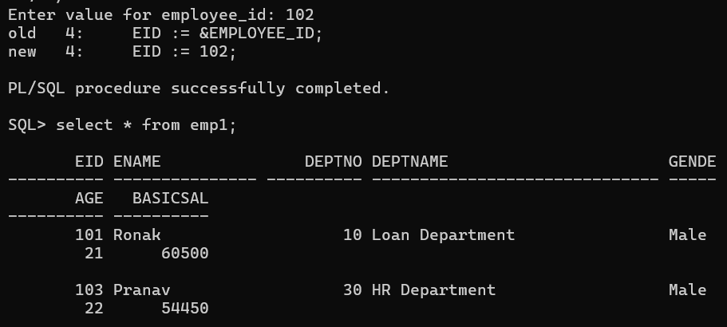
14. Write a function that returns the age category of an employee.
Categories:
Age < 18 -> Minor
18 to 60 -> Adult
Age > 60 -> Senior

CREATE OR REPLACE FUNCTION GET_AGE_CATEGORY (
P_AGE IN NUMBER
) RETURN VARCHAR2
IS
V_CATEGORY VARCHAR2(20);
BEGIN
IF P_AGE IS NULL OR P_AGE < 0 THEN
RAISE_APPLICATION_ERROR(-20001, 'INVALID AGE.');
END IF;

IF P_AGE < 18 THEN
V_CATEGORY := 'MINOR';
ELSIF P_AGE BETWEEN 18 AND 59 THEN
V_CATEGORY := 'ADULT';
ELSE
V_CATEGORY := 'SENIOR';
END IF;

RETURN V_CATEGORY;
END;
/

BEGIN
DBMS_OUTPUT.PUT_LINE(GET_AGE_CATEGORY(15));
DBMS_OUTPUT.PUT_LINE(GET_AGE_CATEGORY(30));
DBMS_OUTPUT.PUT_LINE(GET_AGE_CATEGORY(65));
END;
/

Output:
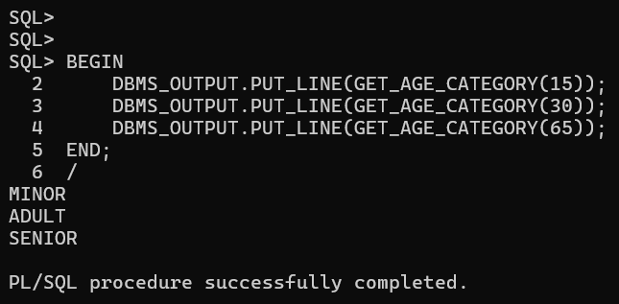

15. Write a PACKAGE which includes Package Declaration, Package
Body and call the individual object from the Package.

-- 1. PACKAGE SPECIFICATION (DECLARATION)
CREATE OR REPLACE PACKAGE MATH_OPERATIONS AS
PROCEDURE ADD_NUMBERS(P_NUM1 IN NUMBER, P_NUM2 IN NUMBER);
FUNCTION MULTIPLY_NUMBERS(P_NUM1 IN NUMBER, P_NUM2 IN NUMBER) RETURN NUMBER;
G_LAST_RESULT NUMBER;
END MATH_OPERATIONS;
/
------------------------------------------------------------

-- 2. PACKAGE BODY (IMPLEMENTATION)
CREATE OR REPLACE PACKAGE BODY MATH_OPERATIONS AS
PROCEDURE ADD_NUMBERS(P_NUM1 IN NUMBER, P_NUM2 IN NUMBER) IS
BEGIN
G_LAST_RESULT := P_NUM1 + P_NUM2;
DBMS_OUTPUT.PUT_LINE('SUM: ' || G_LAST_RESULT);
END ADD_NUMBERS;
FUNCTION MULTIPLY_NUMBERS(P_NUM1 IN NUMBER, P_NUM2 IN NUMBER) RETURN NUMBER IS
BEGIN
G_LAST_RESULT := P_NUM1 * P_NUM2;
RETURN G_LAST_RESULT;
END MULTIPLY_NUMBERS;

END MATH_OPERATIONS;
/
------------------------------------------------------------

-- 3. CALLING PACKAGE OBJECTS
SET SERVEROUTPUT ON;

BEGIN
MATH_OPERATIONS.ADD_NUMBERS(10, 20);
DBMS_OUTPUT.PUT_LINE('PRODUCT: ' || MATH_OPERATIONS.MULTIPLY_NUMBERS(5, 6));
DBMS_OUTPUT.PUT_LINE('LAST RESULT STORED IN G_LAST_RESULT: ' || MATH_OPERATIONS.G_LAST_RESULT);
END;
/

Output:
